BÁO CÁO THỰC HÀNH LAB 2

THỰC HÀNH LẬP TRÌNH HƯỚNG ĐỐI TƯỢNG

**Lab 02: Problem Modeling and Encapsulation**

1. **Assignment Submission**
2. **UML & Astah**
3. **Problem Statement of AIMS Project**
4. **Use case diagram**

Figure 1: AIMS general use case diagram

1. **UML Class Diagram for use cases realted to cart management**

Figure 2: Cart management class diagram

1. **Create Aims class**

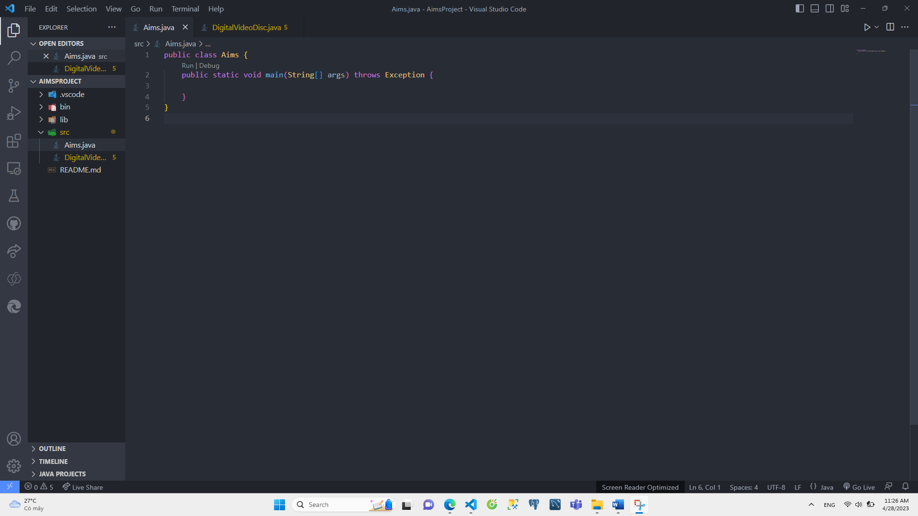

1. **Create the DigitalVideoDisc class and its attributes**

1. **Create accessors and mutators for the class DigitalVideoDisc**

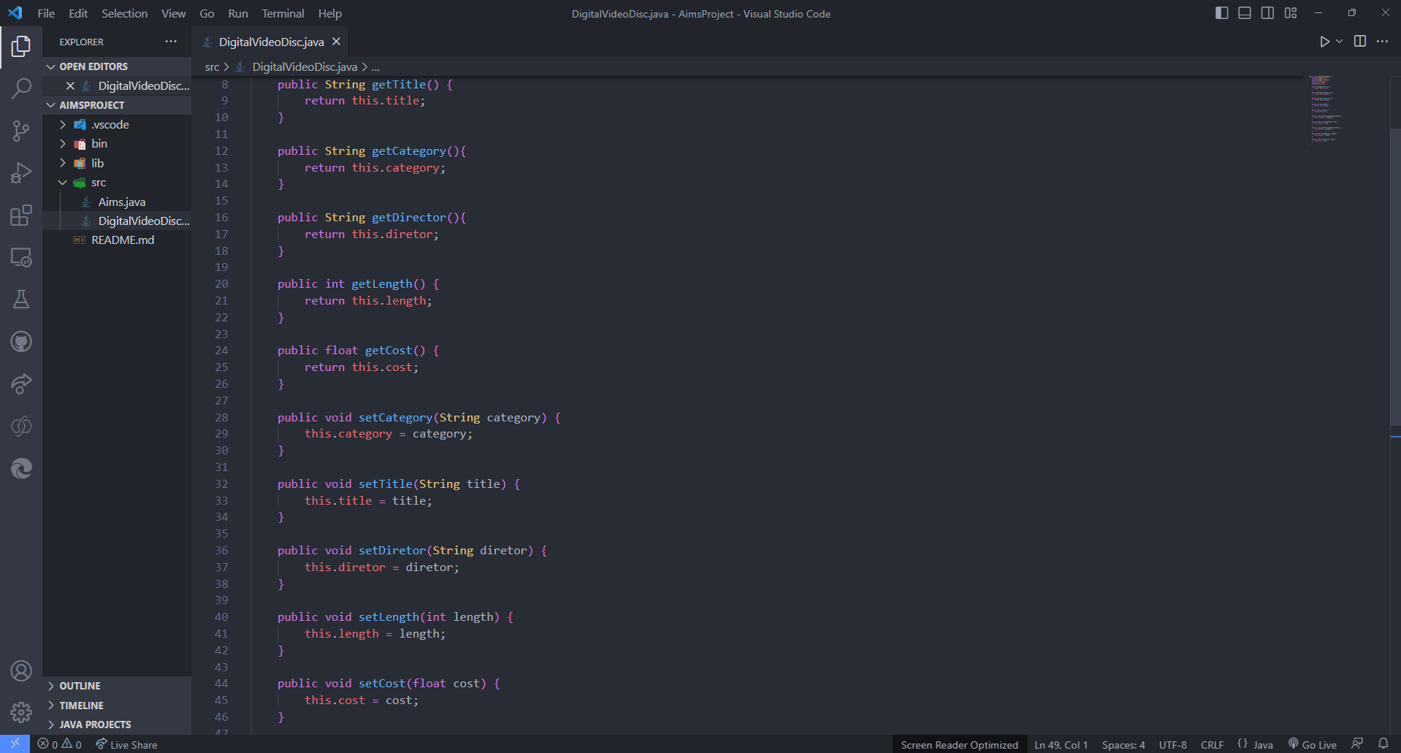

1. **Create Constructor method**

1. **Create Cart class to work with DigitalVideoDisc**

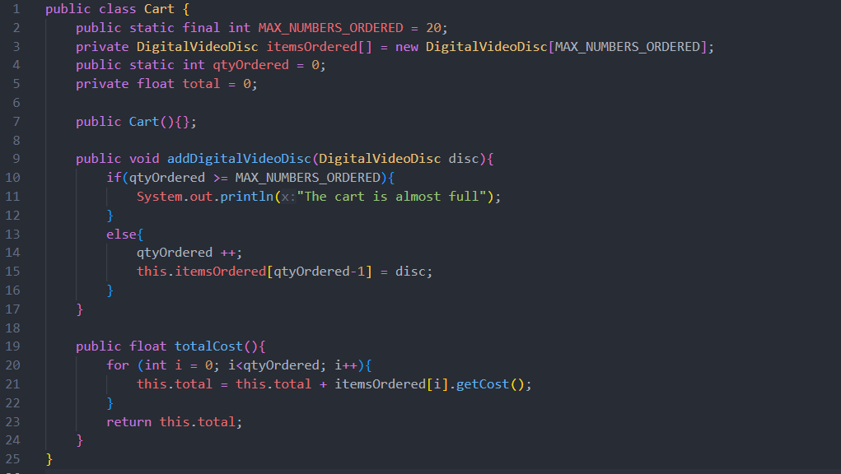

1. **Create Carts of DigitalVideoDiscs**

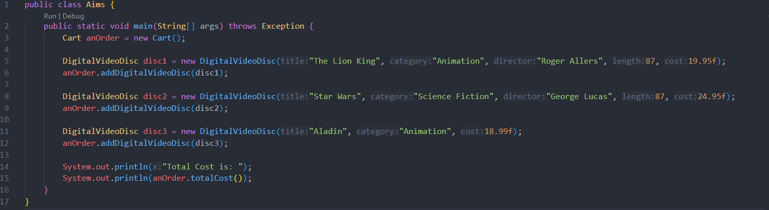

Result:



1. **Removing items from the cart**

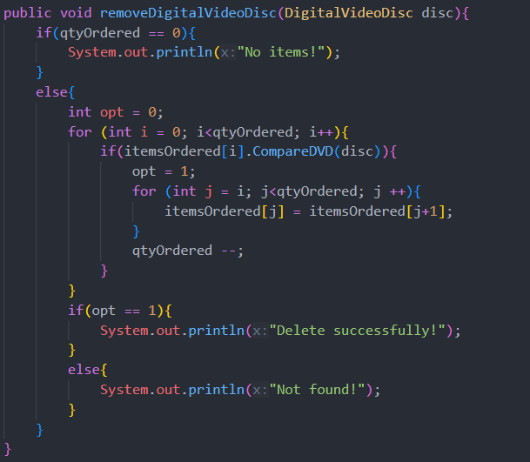

**Result:**

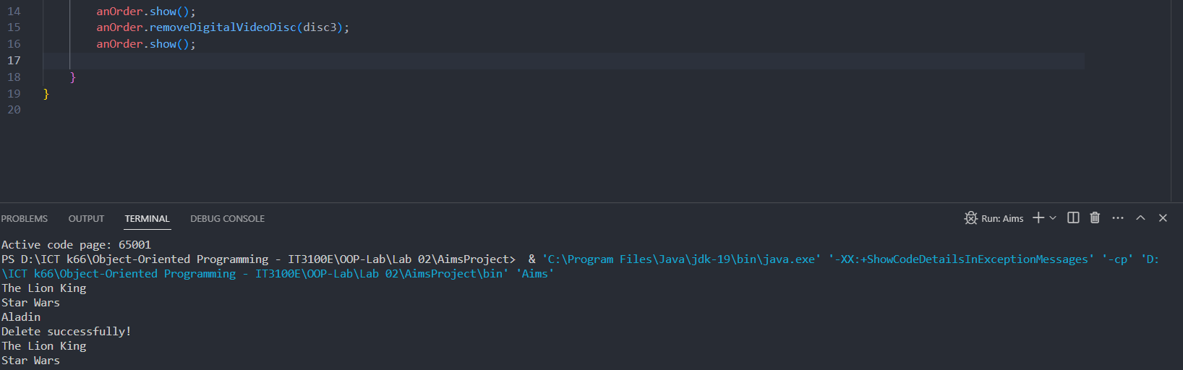

1. **References**

James Rumbaugh, Ivar Jacobson, and Grady Booch (2004). Unified Modeling Language Reference Manual, The (2nd Edition). Pearson Higher Education